
Overview of the College of Engineering and Physical Sciences

College Structure

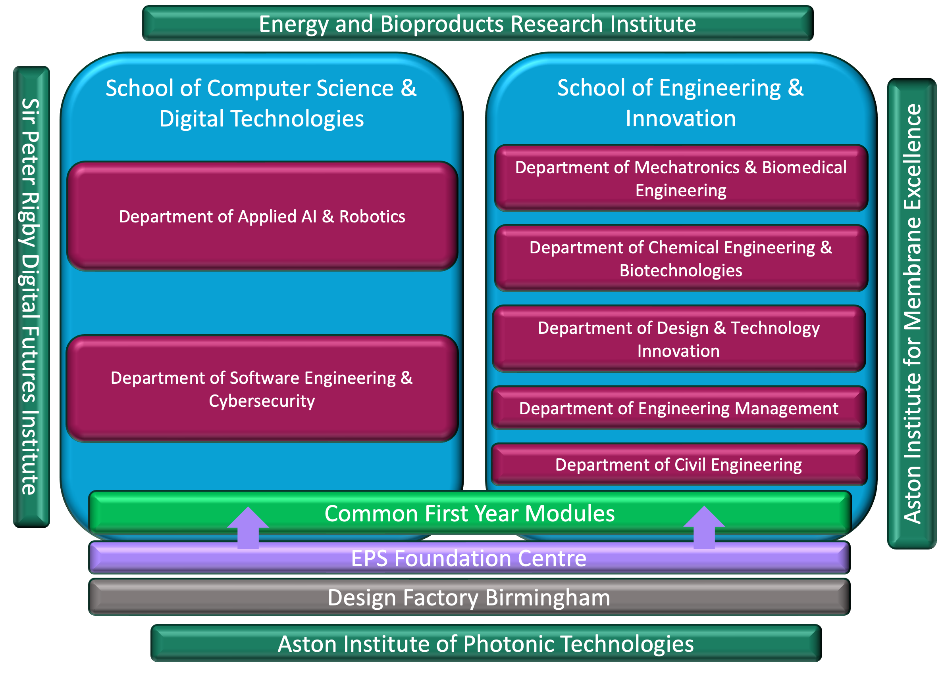
Figure 1 College Structure
The College of Engineering and Physical Sciences has recently undergone a restructure to form an ecosystem consisting of two schools, the Design Factory Birmingham, a Foundation Centre and four University Research Institutes (URIs) that are aligned to cognate EPS disciplines. As of Feb 2026 the college leadership team consisting of Executive Dean and Deputy Deans is removed so that the ecosystem has a leadership team consisting of two Executive Deans of Schools, a Director of DFB and a Head of Foundation Centre. Deputy Deans of Research, Education, and International remain associated with the ecosystem, but operate out of the respective directorates led by members of the University Executive.

The Design Factory Birmingham is a facility that provides a space for university-company collaborative projects. This was established in 2023 and has been recently successful in attracting external funding for both staff and student-based projects. This is a relatively unique offering and is expected to grow rapidly offering the same service across the the rest of the university.

The Foundation Centre is led by a Head with a team of education focussed academics. It runs a series of successful (c. 300 students) foundation degrees which feed into year 1 of all of our standard degree programmes. In addition the Foundation Centre academics support year 1 delivery to maximise efficiency and free up some academic time in schools for research.

Staff Resources

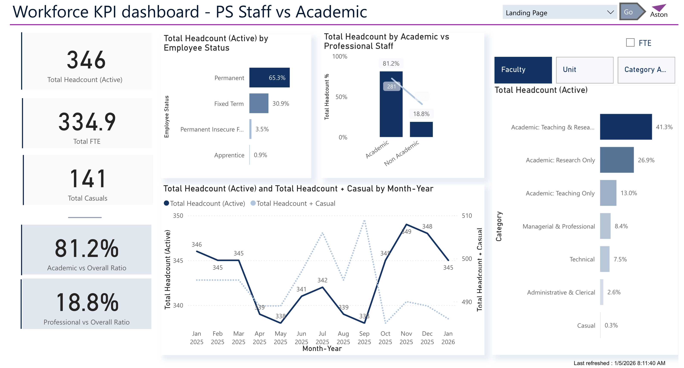
Figure 2 Staff Resources

Staffing resources are shown in Figure 2. Professional Services staffing throughout Aston University has been recently centralised based on a service agreement model. In addition, new school-based professional services teams have been created to reinforce the move from College- to School-based operations.

Most staff in EPS are on both Teaching & Research academic contracts. A small number, predominantly in the Foundation Centre, are on Teaching Only contracts. Virtually no permanent staff are on Research Only contracts, the number of staff who are shown as research only are made up of fixed term research contracts. We continue to review those staff on fixed term research contract in order to offer them permanent contracts subject to performance and the potential to continue as research stars and/or effectively contribute to education delivery.

Staff growth in the school of Computer Science & Digital Technology has lagged student recruitment growth in recent years potentially compromising the opportunity to achieve research targets in an important REF unit of assessment.

Staff resourcing in the Foundation Centre is an important part of the EPS strategy since we have seen grown in foundation degree student numbers in recent years and FC staff can support teaching across all undergraduate degrees due to the recent creation of consolidated education frameworks. The current strategy is to gradually increase the FC staff subject to the continued growth.

Student Recruitment
National student recruitment is dependably strong in EPS, particularly from regional commuting students. International students (predominantly PGT) has weakened recently predominantly due to government actions such as visa restrictions. EPS is fully engaged with all Omnichannel activities such as delivery in Aston London and Aston Online. These appear to be growing and EPS was able to exceed its surplus requirement of 52% by 4%. Current developments include a new BEng Aerospace which is due to start in Sept 2026 which has had good interest in recent open days.

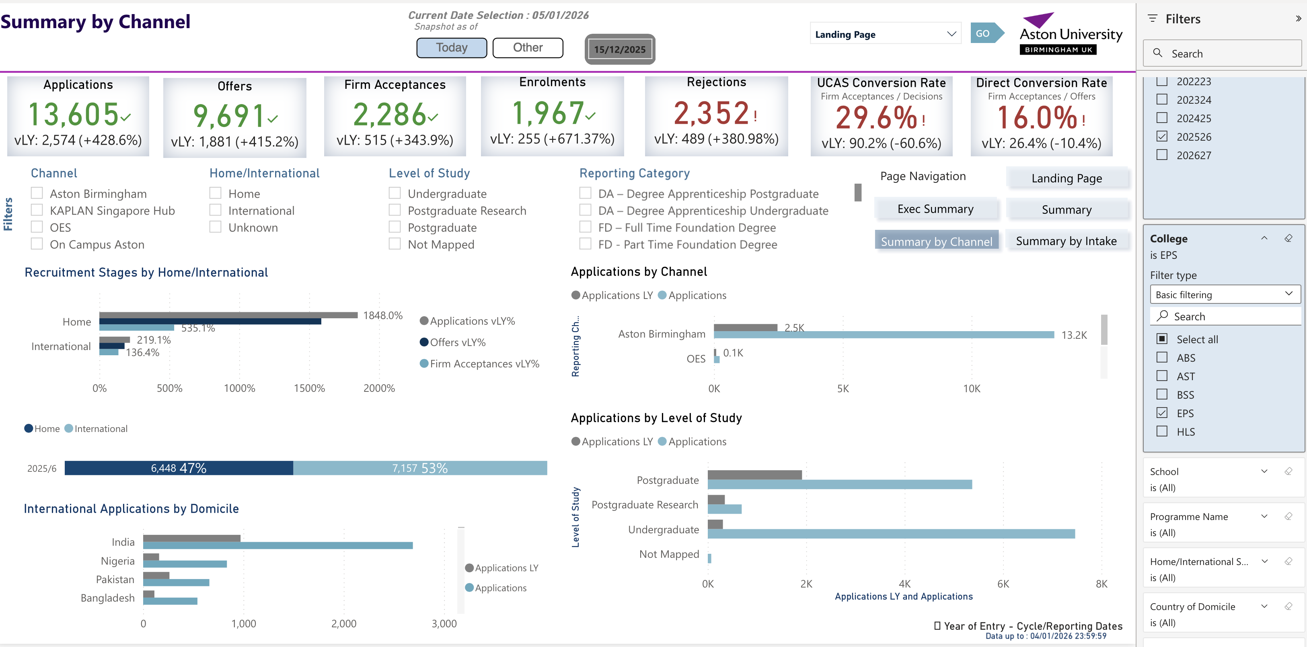
Figure 3 Student Recruitment in EPS

Research
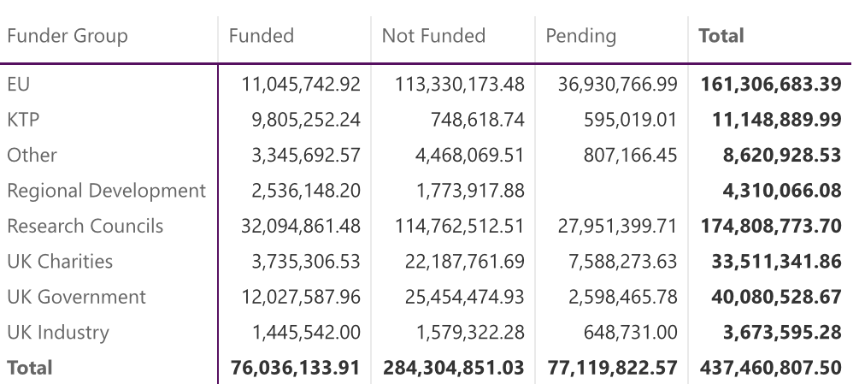
Figure 4 Research Income

Most members of academic staff in EPS are contracted to undertake research and are members of either University Research Institutes (large scale units, often pan university, that operate with their own directors and budgets) or smaller scale (school or department) centres/groups.

AIPT is a Photonics (communications) institute which is mainly aligned to EPS and which is highly ranked both nationally and internationally. It has recently secured around £5m to lead the national centre for Neuromorphic Computing and is currently seeking to acquire a professor to lead the centre from Aston.

AIME is a membrane institute that addresses issues such as separating and cleaning chemical mixtures. It was set up with c. £10m from national research funds and collaborates across many other institutions. It is already demonstrating growth with several large scale grants.

The Sir Peter Rigby Digital Futures Institute has been operating for 3 years and has secured a modest amount of grants, mainly as KTPs. It is poised for the next stage of growth with opportunities to collaborate with digital research centres across the university.

EBRI is a bioenergy research institute which is supported by a range of external funding including leading the national Supergen project. It has recently been awarded lead for a Centre for Doctoral Training in energy.

Until recently, the budgets for the institutes have been absorbed into the EPS college budget. With the move to school-based budgeting, the institutes will need to become more autonomous in terms of their financial operations. It is expected that this move will be facilitated by a review of institute planning and monitoring.

The funding across the EPS ecosystem is shown in Figure 4. This is extremely healthy although it contains infrastructure funding for EBRI and AIME, CDT support in EBRI, and the setup costs for the Centre for Neuromorphic Computing, all of which are large one-off multi-year scheme for supporting research development. The pipeline of research grant submissions continues to be healthy although the excellence in research as defined by grant success and 4* outputs is limited to a relatively small number of individuals. In recognition of this EPS has been working on a scheme to support grass root research development, early career research and to create a framework for setting research expectations and measure performance.

Education

Teaching across EPS has recently been reviewed by a major pan-college project with the aim of achieving excellence in student outcomes, experience whilst improving the efficiency of delivery. The resulting set of education frameworks started operation in Sept 2025 and will gradually replace the current programmes as their cohorts progress. The key feature of the new frameworks is a consolidated first year which includes a focus on authentic assessments, in-module assessment, flexible referrals, project work, interdiciplinary collaboration, and employability. The consolidated first year includes the pan-university requirement to deliver the Aston Power Skills learning outcomes.

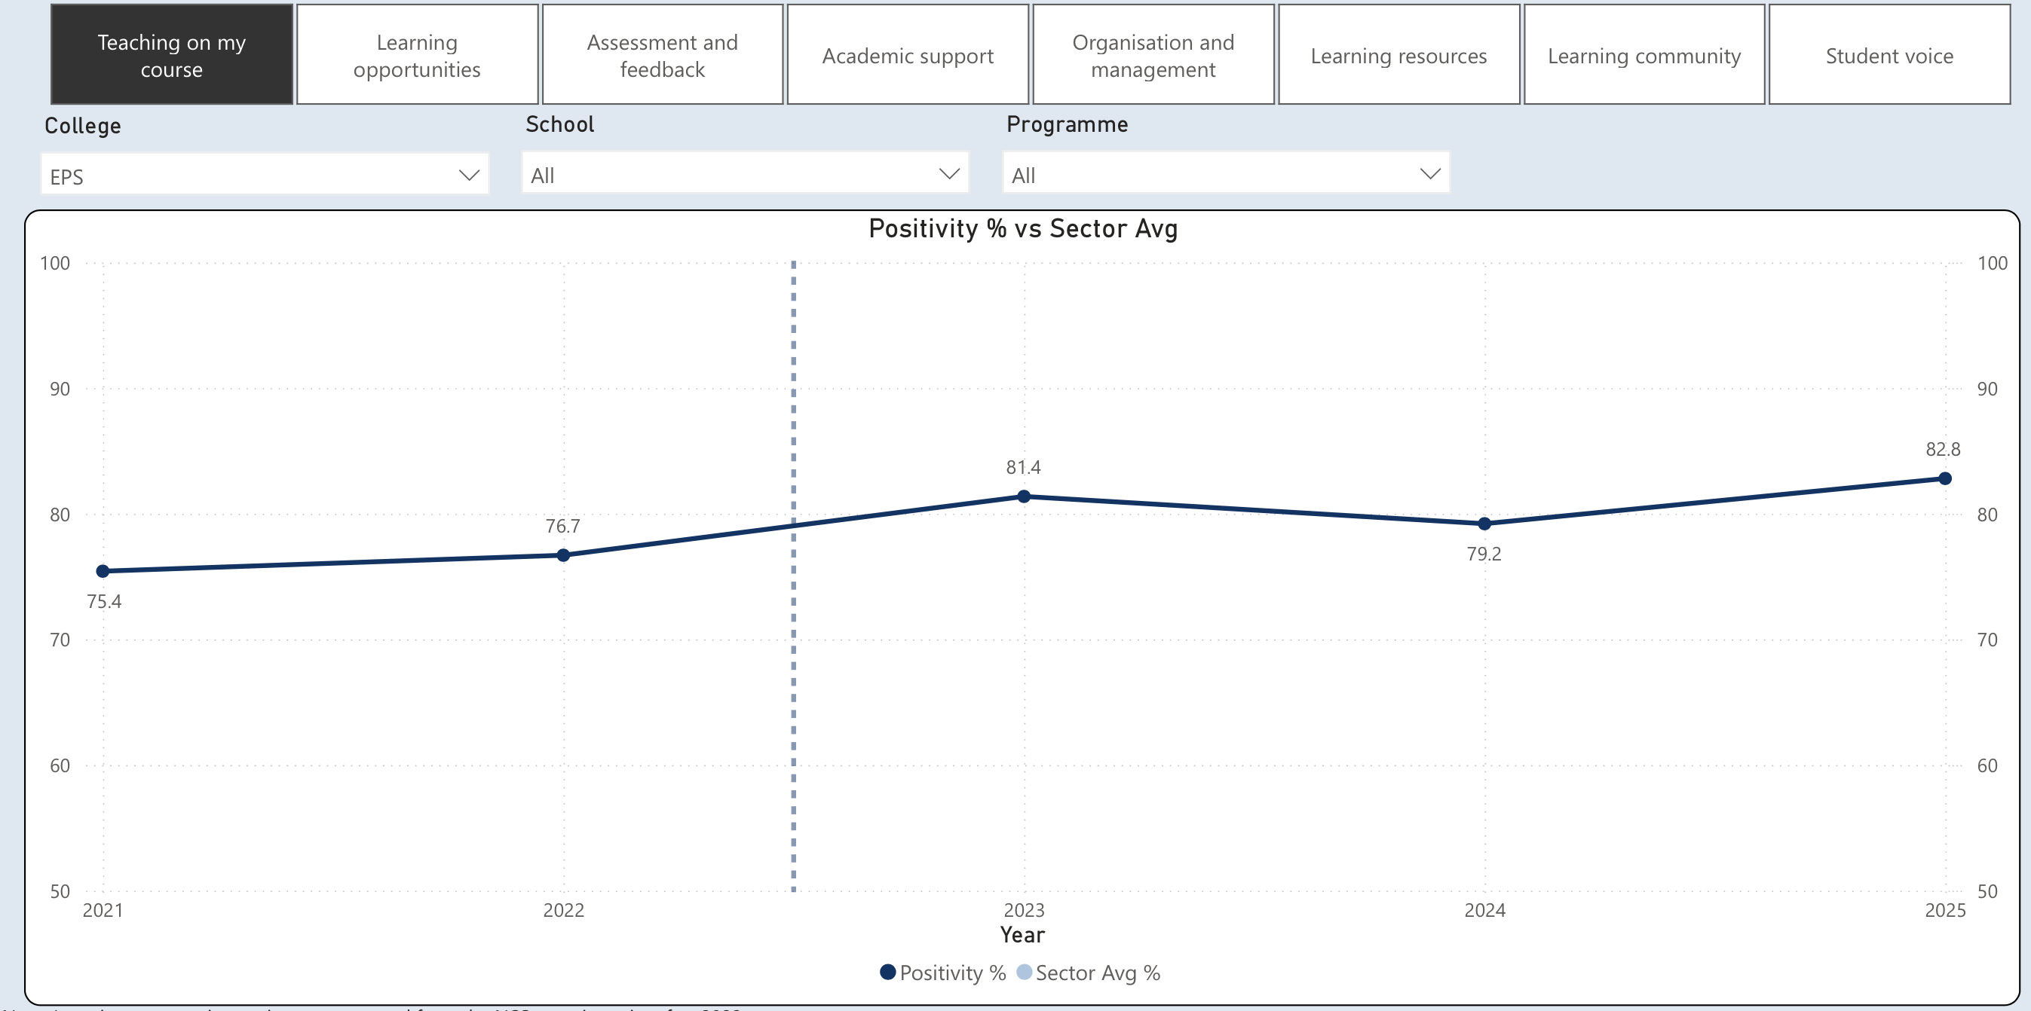
Figure 5 NSS Overall Satisfaction
The quality of education provision as measured by the NSS has been improving overall, but is not yet in the top 10 as targeted by the Aston 10 strategic plan. There are areas of very high quality provision as shown by Figure 5, however some areas require improvement. So far the new education frameworks are well received by students (and staff) and the schools are supported by the DVC(A) directorate to establish and implement improvement plans on an annual basis.

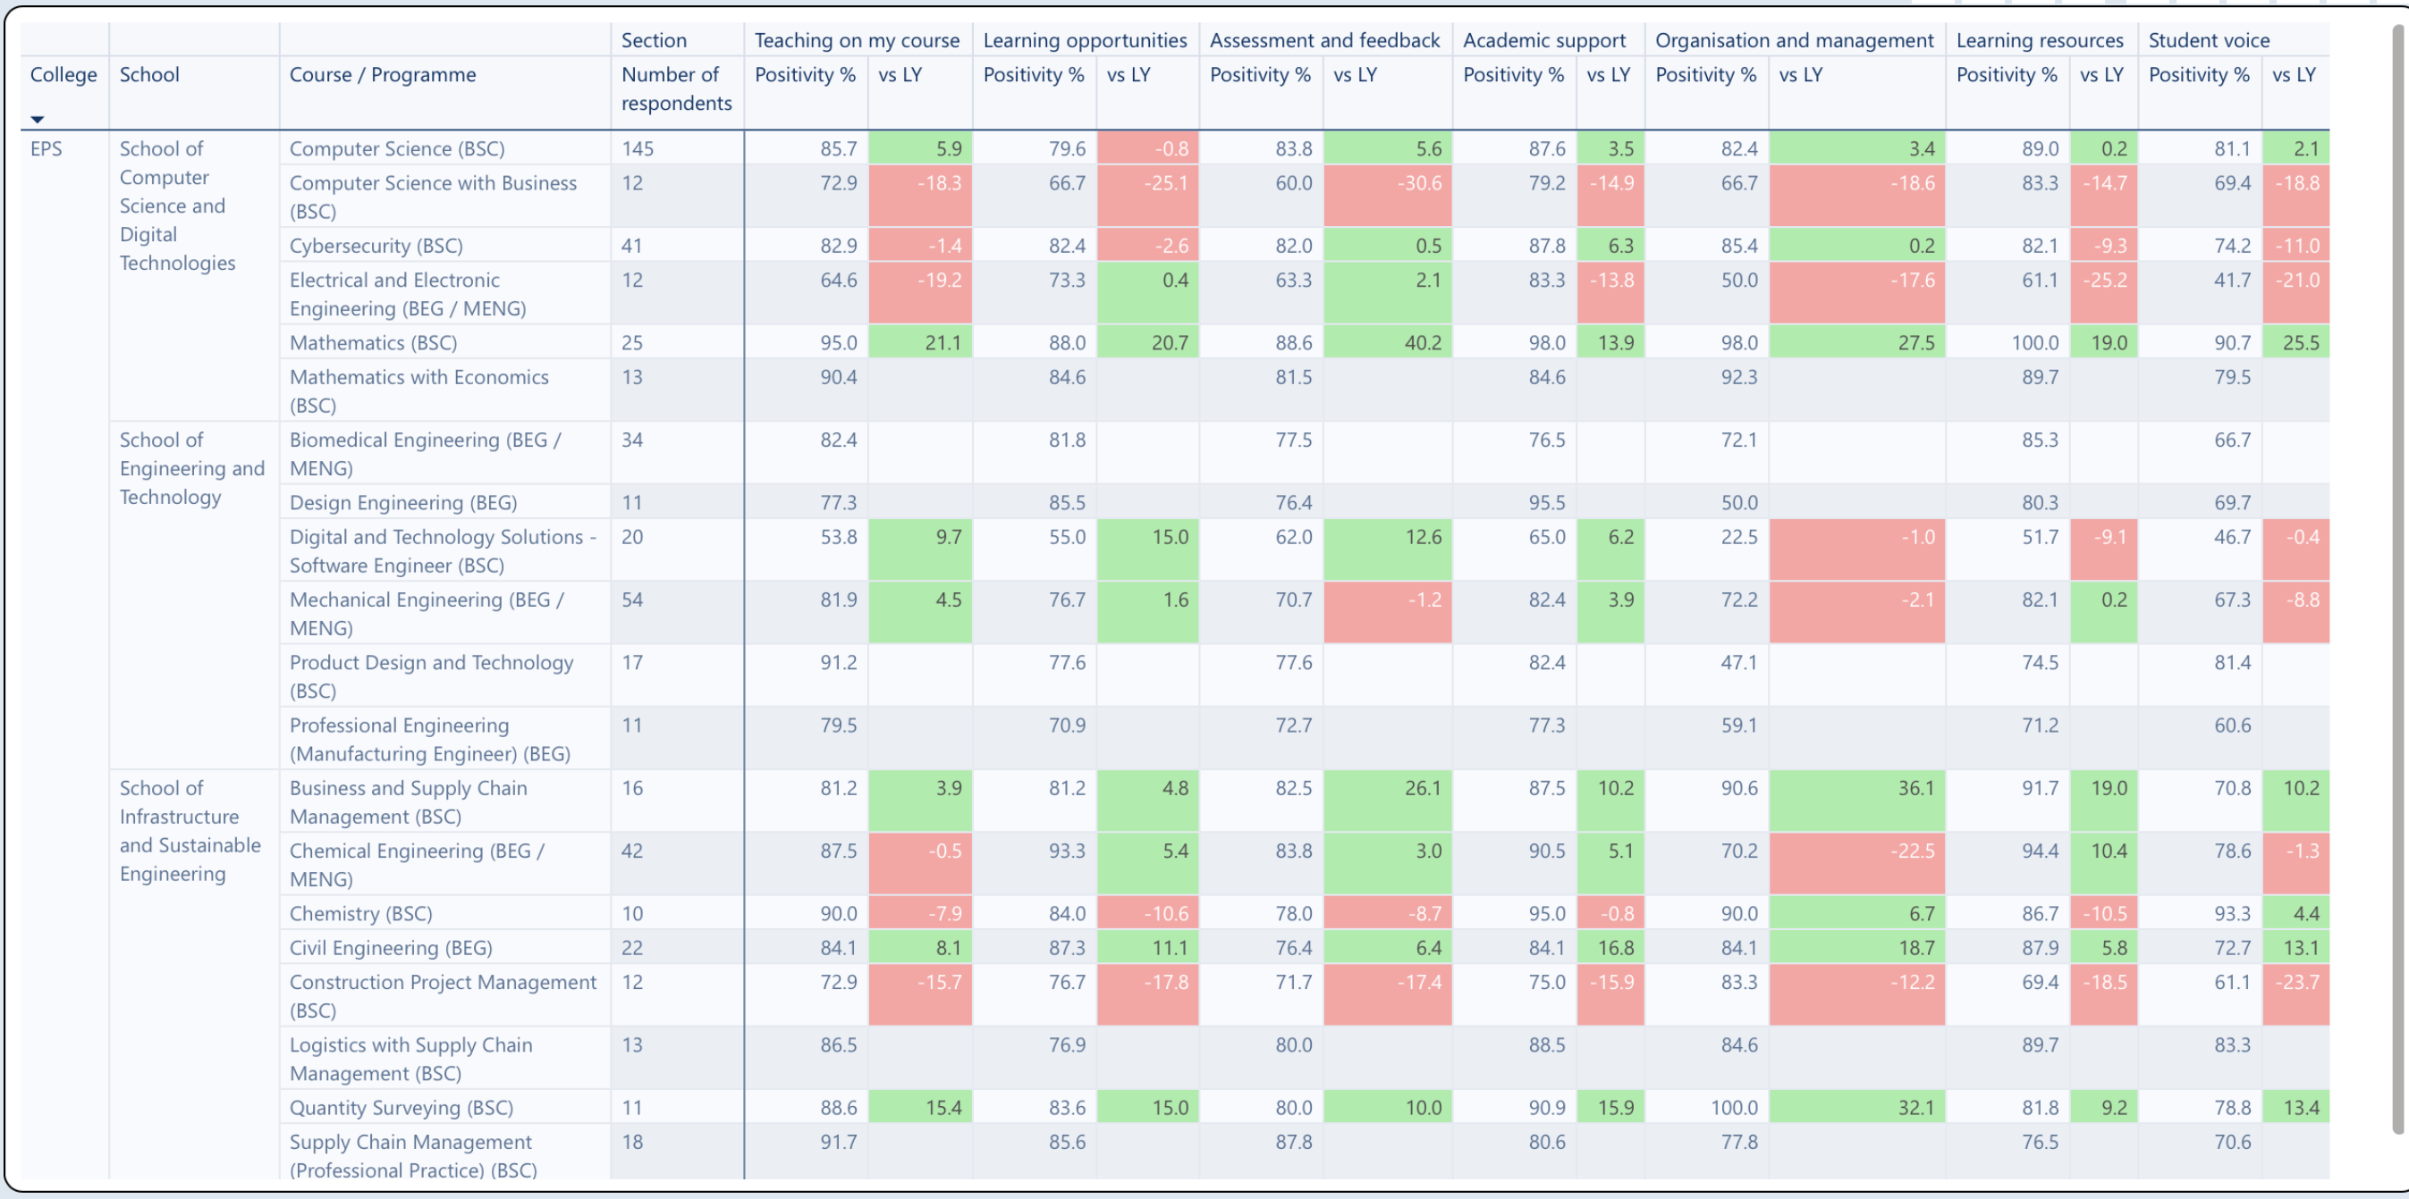
Figure 6 NSS Results for EPS Programmes

